BOOK CHART — JONAH 1:1–4:11
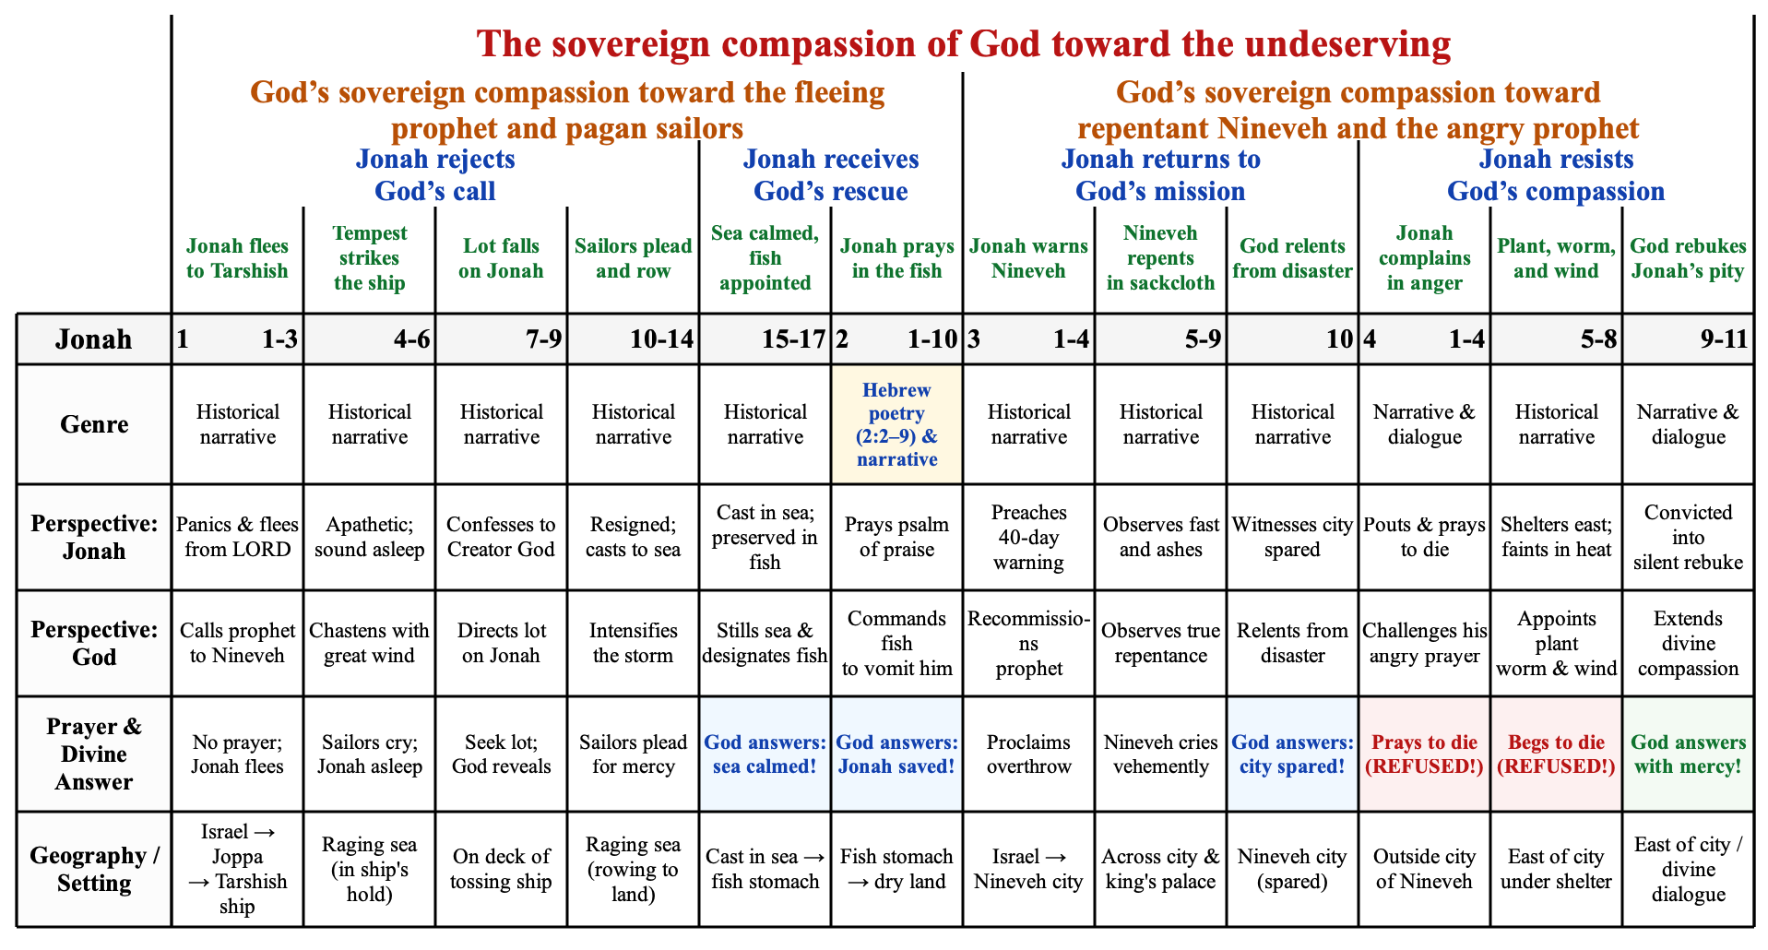

David Guzik, “Mark 1- The Beginning of the Gospel.” Enduring Word, 1996, accessed September 9, 2026, https://enduringword.com/bible-commentary/mark-1/.
Guzik, “Mark 1- The Beginning of the Gospel.”
John D. Grassmick, “Mark,” in The Bible Knowledge Commentary. Gospels, eds. John F. Walvoord and Roy B. Zuck. (Colorado Springs, CO: David C. Cook, 2018), 27o, accessed September 7, 2026, ProQuest Ebook Central, https://ebookcentral-proquest-com.dtl.idm.oclc.org/lib/dtl/reader.action?docID=5310204&ppg=136&c=UERG.
Grassmick, “Mark,” 27t.
Darrell Brock, “Mark.” In New Cambridge Bible Commentary (Cambridge: Cambridge University Press, 2015), 23, accessed September 9, 2026, https://www-cambridge-org.dtl.idm.oclc.org/core/books/mark/301290520AF7FF4B35C1A13FE1BCFC7F.
Brock, New Cambridge Bible Commentary, 23.
Grassmick, “Mark,” 27t.
Grassmick, “Mark,” 27t.
Grassmick, “Mark,” 27w.
Grassmick, “Mark,” 27w.

